*Florida International University*

*School of Computing and Information Sciences*

Software Engineering Focus

Feature Document

User Story ID 328

**Name:** Automatically Logout User After Being Idle for Timeout Period

**Team Member(s):** Darilys Pereira

**Project:** Virtual Roll Call 4.0

**Product Owner(s)**: Jason Cohen

**Mentor(s)**: Juan Caraballo

**Instructor**: Masoud Sadjadi

**User Story Name:**Automatically logout user after being idle for timeout period

* Description: **As a** user **I would like** to to be logged out after being idle for timeout period **so that** my account is protected.

Acceptance Criteria

* After being idle for timeout period, show pop-up window advising the user that the section will be closed if they don’t take action.
* User should be able to move the mouse and continue working on site to prevent section from closing.
* Pop-up will display on screen for 60 seconds. If user does not take action, the section will terminate.

**Use Case**

* Name: Session Timeout
* Actor: Officer
* Preconditions:

1. System is up and running
2. User has successfully logged into the system.
3. Connection to the database has been established.

* Description:

1. User has been idle for number of minutes specified in site settings.
2. When idle warning message is displayed, user can either move mouse or click anywhere in the page and the timeout countdown will be aborted.
3. When idle warning message is displayed and user does not take action within 60 seconds, user session is terminated and user is displayed a message.

**Use Case Diagram**

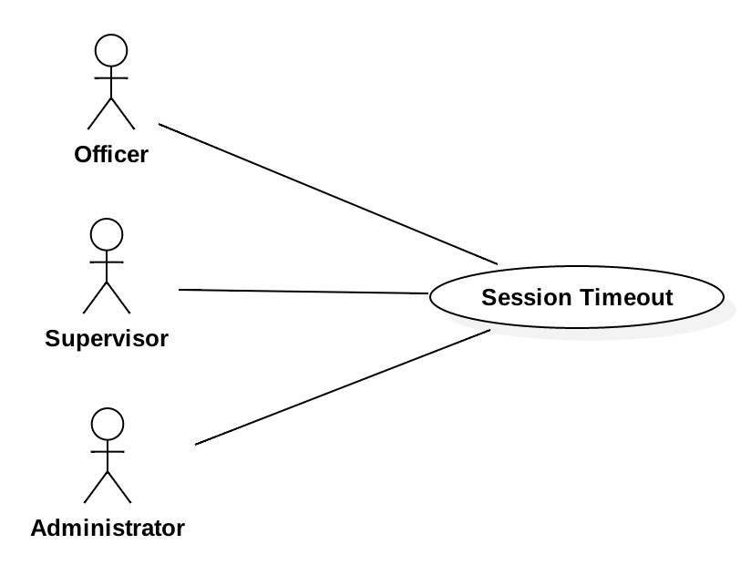

**Sequence Diagram**

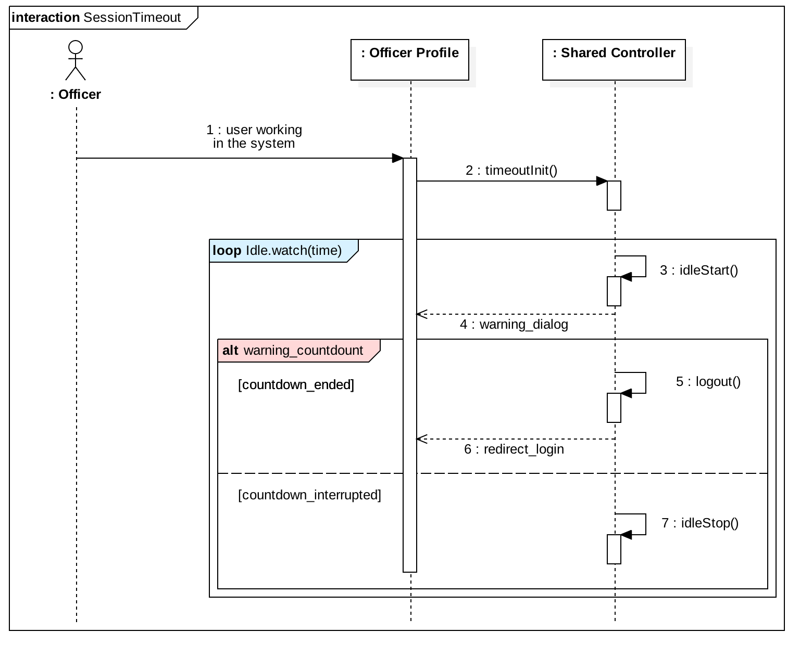

**Class Diagram**

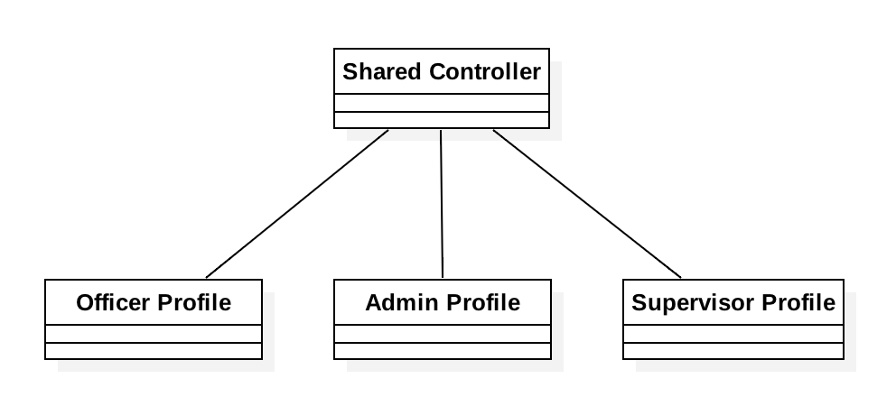

**Unit Test**

Test 1

* Test case ID: User Story #328 - Session Timeout -U1
* Description/Summary of Test: Verify session is terminated if user is idle for the timeout period.
* Pre-condition:

1. User is logged in.
2. System has read the database value for timeout period and it’s “watching” for inactivity.

* Expected Results: If user has been inactive for the timeout period configured in the Site Settings system should display a pop-up window advising user the session will be terminated if no action is taken. If user continued being inactive for 1 more minute. Destroy user account.
* Actual Result: User was inactive for 15 minutes (site settings). Warning message was displayed. User did not take action and session was terminated.
* Status (Fail/Pass): Passed.

Test 2

* Test case ID: User Story #328 - Session Timeout Cancelled-U2
* Description/Summary of Test: Verify session is not terminated if user does some work in the site during warning countdown.
* Pre-condition:

1. User is logged in.
2. System has read the database value for timeout period and it’s “watching” for inactivity.
3. User has been inactive.
4. Session Timeout warning message has been displayed.

* Expected Results: During 1 minute countdown if user navigates to a page, clicks somewhere or presses a key countdown should stop and session should not be terminated.
* Actual Result: While countdown was displayed on the screen user took action by pressing a key. Countdown stopped and user continued working in the site with an active session.
* Status (Fail/Pass): Passed.

**Integration Test**

Tested system by:

1. Being idle from Administrator, Supervisor, and Officer pages. All pages behaved identical.
2. Cancelling the timeout during warning by pressing key, clicking and navigating to another page.

Status : Passed

**Visual User Guide**

